Lab 6 Functions Revisited [ANSWER KEY]

Instructions
- Answer the below question in the boxes if needed.
- Code on your computer and zip all your code before submission.
- Please submit the assignment after you finish.

Part 1 Functions

1.1 Code Dry-running
In this section, you don’t need to write any code. Just try to run the code in your mind or on a piece of paper. DO NOT test the code with your computer.

Question 1.1 What’s the console output of the following statements? (Hint: the results might be more than 1 line)

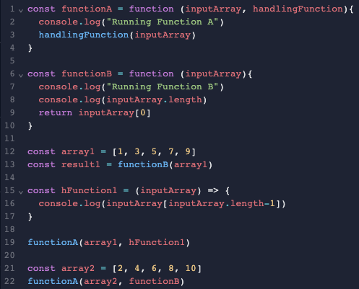
const functionA = function(inputArray, handlingFunction){
console.log("Running Function A")
handlingFunction(inputArray)
}

const functionB = function (inputArray){
console.log("Running Function B")
console.log(inputArray.length)
return inputArray[0]
}

const array1 = [1, 3, 5, 7, 9]
const result1 = functionB(array1)

const hFunction1 = (inputArray) => {
console.log(inputArray[inputArray.length-1])
}

functionA(array1, hFunction1)

const array2 = [2, 4, 6, 8, 10]
functionA(array2, functionB)

Answer 1.1

Running Function B
5
Running Function A
9
Running Function A
Running Function B
5

Question 1.2 What’s the console output of the following statements? (Hint: the results might be more than 1 line)

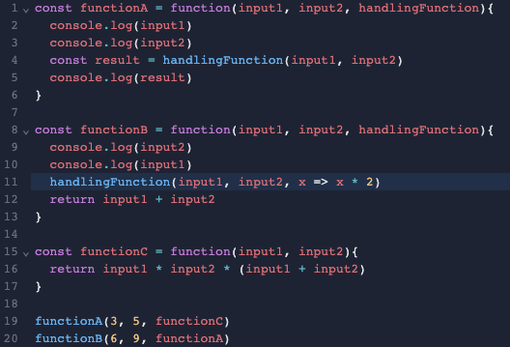
const functionA = function(input1, input2, handlingFunction){
console.log(input1)
console.log(input2)
const result = handlingFunction(input1, input2)
console.log(result)
}

const functionB = function (input1, input2, handlingFunction){
console.log(input2)
console.log(input1)
handlingFunction(input1, input2, x => x * 2)
return input1 + input2
}

const functionC = function(input1, input2){
return input1 * input2 * (input1 + input2)
}

functionA(3, 5, functionC)
functionB(6, 9, functionA)

Answer 1.2

3
5
120
9
6
6
9
12

Part 2 Rewriting Functions into Arrow Functions

2.1 Code Rewriting
Please rewrite the code block below by using Arrow Functions. Then test it with repl.it.
You can paste a screenshot or type the code in the answer box.

Question 2.1.1
Original Code:
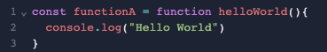
Rewritten Code:
const functionA = () => {
console.log("Hello World")
}

Question 2.1.2
Original Code:
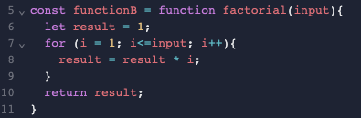

Rewritten Code:
const functionB = (input) => {
let result = 1;
for(i = 1; i<=input; i++){
result = result * i;
}
return result;
}

Question 2.1.3
Original Code:
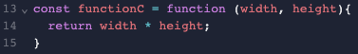

Rewritten Code:
const functionC = (width, height) => {
return width * height;
}

Question 2.1.4
Original Code:
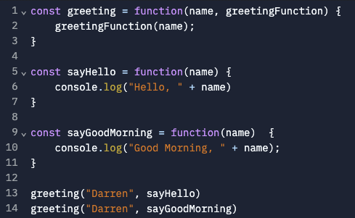

Rewritten Code:
const greeting = (name, greetingFunction) => {
greetingFunction(name);
}

const sayHello = (name) => {
console.log("Hello, " + name)
}

const sayGoodMorning = (name) => {
console.log("Good Morning, " + name);
}

greeting("Darren", sayHello)
greeting("Darren", sayGoodMorning)

